Select ('exec sp_change_users_login ''auto_fix'''+',' +'''' + name + '''')

from sysusers

where name not like 'db_%'

and sid <> 'NULL'

order by name

1. Run the script on the DB level (instead of master DB).
2. Run the result of the script.
3. Rerun Exec sp_change_users_login 'report'

Below is an example.

1. Run the script on the DB level (instead of master DB).

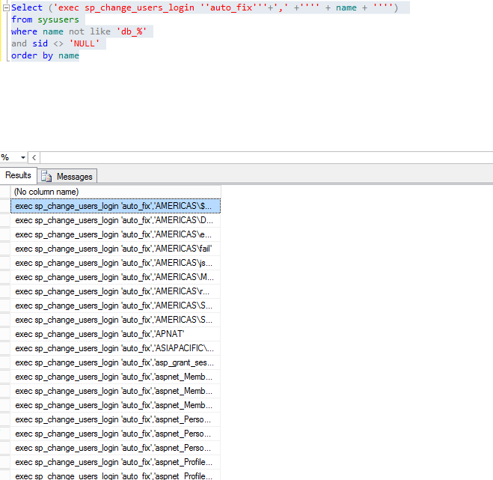

1. Copy the results and run the queries.

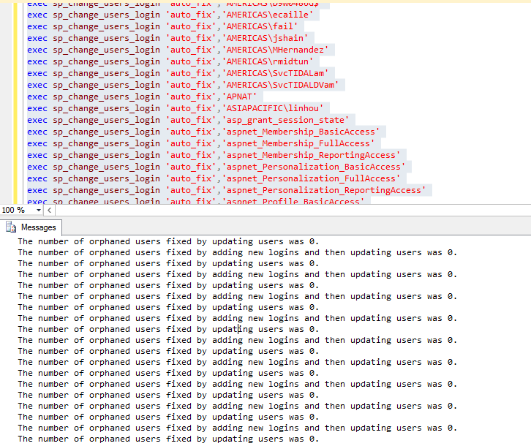

1. Rerun Exec sp_change_users_login 'report'